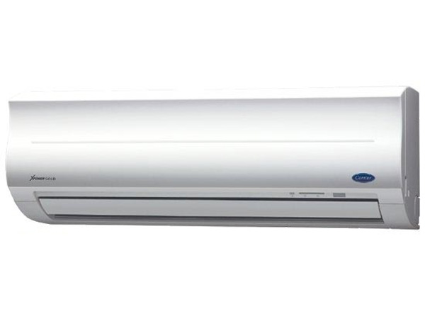

**12,620,000 VND**

**Air conditioner Carrier 38/42 CER 018 18,000BTU Gas R410A**

**Specifications**

* Type of air conditioner1 pm
* Usable area24m2 - 30m2
* Installation typeWall mounted
* Inverter technologyAre not
* Copper tube sizeF6.35
* Maximum installation height between hot and cold units8m
* Copper pipe installation length20m
* Power Consumption1.96kW
* Voltage source220V - 240V / 50Hz
* Guarantee24 months
* Made inThailand
* Brand originAmerica

**Indoor unit parameters**

* Size of indoor unitWidth x height x depth *(105cm x 32cm x 23.8cm)*
* Volume of indoor unit14kg
* Cooling capacity18,000 BTU - 2HP

**Outdoor unit parameters**

* Size of outdoor unitWidth x height x depth *(78cm x 55cm x 29cm)*
* Mass of outdoor unit39kg
* Gas usedR410A

## Explore the features of Carrier 38/42 CER 018 air conditioners

Compared to conventional air conditioners, the **Carrier 38/42 CER 018** air conditioner has a new technology, Nano technology, to quickly freshen the air in the room.

With a cooling capacity of 2.0 HP, [the 1-way air conditioner](https://meta.vn/dieu-hoa-1-chieu-c1039) is capable of meeting the cooling needs of rooms with an area of ​​24 - 30 m2 or 72 - 90 m3 of air (suitable for living rooms and offices).

**>> Find out** :  [Which country's Carrier air conditioners and air conditioners are good?](https://meta.vn/huong-dan/tu-van/danh-gia-may-lanh-dieu-hoa-carrier-8980)

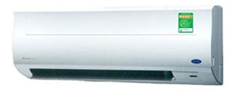

Nano Silver Ginseng filter and Nano Photo Copper Zinc filter are effective in removing odors, bacteria, and mold in the air. Thanks to this technology, [air conditioning](https://meta.vn/dieu-hoa-c1018) brings fresh air, ensuring health safety for your whole family.

[Carrier 38/42 CER 018 1-way air conditioner](https://meta.vn/dieu-hoa-1-chieu-c1039?brands=2633) also operates very smoothly, does not make noise but saves energy effectively. You just need to press the E button on the remote control to activate the energy saving feature for the air conditioner.

In addition, the wide air flap helps the cold air spread throughout the room, cooling down as quickly as possible. You can use the remote control to adjust the wind direction up and down as desired.

**>> See now** :  [How to use the air conditioner control, Carrier air conditioner remote](https://meta.vn/huong-dan/tu-van/cach-su-dung-dieu-khien-dieu-hoa-remote-may-lanh-carrier-9016)

**Note:** Product images are for illustration purposes only, product details, colors, designs and specifications may vary depending on the actual product without prior notice.